**Establish and Manage Azure SQL DB service**

We should have a **Management Group** under that we can have one or more an **Azure Subscription(s)**.

Under each **Azure Subscription,** we can create a one or more **Resource Group(s)**.

Under each Resource Group, we can create **different types of Resources** as given below,

* **SQL DB Server**
* **DB Schema** (we can have multiple schemas based on the requirement)
* **Key Vault** - To store the credentials of different types of resources.
* **Log Analytics** - We can check and analyze the logs of DB.
* **Storage Account** - we need to create the storage account. This account provides File and Blob storage services to store the logs in the form of xel

We must get one of the following roles to log in Azure Portal to monitor and manage the different types of the resources.

* **Reader**
* **Contributor**
* **Owner**
* **Administrator**

These roles are provided at the **Azure Subscription Level.**

**Ref Link :** <https://learn.microsoft.com/en-us/azure/role-based-access-control/role-assignments-portal>

To get the contributor role, we must raise **Privileged Identity Management** (PIM) request.

**Azure Data Studio** is used to connect the Azure SQL DB Schema. It is like a client in the local environment to connect the Azure SQL DB server and the specific Azure SQL DB schema.

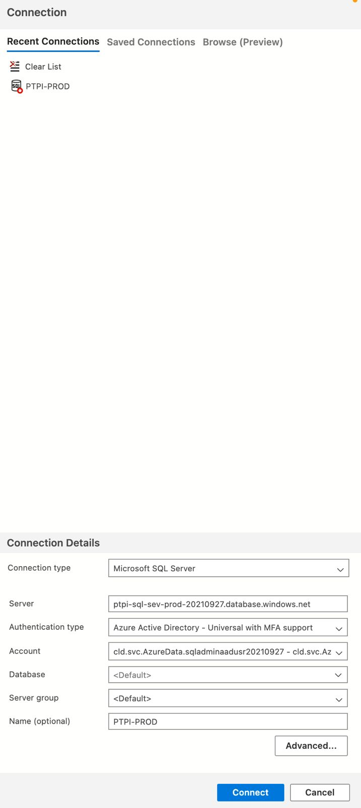

Using the **Contributor Role**, we must do the following steps to access Azure SQL DB server and its DB schema from the local machine.

* We need to add a firewall rule at server level.
* We need to whitelist our IP address (Just add our IP address displayed in the Azure Portal)

We have two types of user credentials to connect as well as manage the DB schema from Azure YAML based pipeline and to connect from the Microservices deployed in Azure-PCF cloud environment.

**PCF AAD User** - This credential is used to connect the DB schema from the Applications/Microservices deployed in Azure-PCF cloud environment.

**SQL Admin AAD User** - This credential is used to Manage DB schema through Azure YAML pipeline for the managing reset of password of the PCF AAD user credential.

* Reset Password Pipeline **(Azure YAML based pipeline)** will be run monthly as cron job.
* Create a temp user credentials and update the same to the **CredHub** of the applications deployed in the different CFs on Azure Cloud environment.
* And then **Re-stage the applications One by One in different CFs** to make sure that the applications use the new temporary credentials to connect to Azure SQL DB temporarily.
* Reset the password of the actual PCF AAD User which is generally used by the application.
* Store the **password-updated PCF AAD User credentials** in **Key Vault**
* And then update the same credentials (with new password) to **CredHub.**
* And then **Re-stage the applications One by One in different CFs** to make sure that the applications start using the latest PCF AAD User credentials (with new password) to connect to Azure SQL DB

Note:

**Connections are made at DB server level, not at the DB schema level.**

**Purchase Models**

Azure SQL Database lets you easily purchase a fully managed platform as a service (PaaS) database engine that fits your **performance and cost needs**.

There are two purchasing models available such as **vCore based Purchasing Model** and **DTU based Purchasing Model**.

**Depending on the deployment model you've chosen for Azure SQL Database**, you can select the purchasing model that works for you:

* [**Virtual core (vCore)-based purchasing model**](https://learn.microsoft.com/en-us/azure/azure-sql/database/service-tiers-sql-database-vcore?view=azuresql) (recommended). This purchasing model provides a choice between the **provisioned or serverless compute tiers**:
  1. With the **provisioned** **compute tier**, you choose the **exact amount of compute resources** that are always provisioned for your workload.
  2. With the **serverless** **compute tier**, you specify the **autoscaling of the compute resources over a configurable compute range**. The serverless compute tier automatically pauses databases during inactive periods when only storage is billed and automatically resumes databases when activity returns. **The vCore unit price per unit of time is lower in the provisioned compute tier than it is in the serverless compute tier.**
* [**Database transaction unit (DTU)-based purchasing model**](https://learn.microsoft.com/en-us/azure/azure-sql/database/service-tiers-dtu?view=azuresql)**.** This purchasing model provides **bundled compute and storage packages** balanced for common workloads.

**Note:**

1. The **vCore-based purchasing model** is available for both [Azure SQL Database](https://learn.microsoft.com/en-us/azure/azure-sql/database/service-tiers-vcore?view=azuresql) and [Azure SQL Managed Instance](https://learn.microsoft.com/en-us/azure/azure-sql/managed-instance/service-tiers-managed-instance-vcore?view=azuresql).
2. The **DTU-based purchasing model** is available for [Azure SQL Database](https://learn.microsoft.com/en-us/azure/azure-sql/database/service-tiers-dtu?view=azuresql).

|  |  |  |
| --- | --- | --- |
| **Purchasing model** | **Description** | **Best for** |
| DTU-based | This model is based on **a bundled measure of compute, storage, and I/O resources**. Compute sizes are expressed in **DTUs for single databases** and in elastic database transaction units **(eDTUs) for elastic pools** | Customers who want simple, preconfigured resource options |
| vCore-based | This model allows you to **independently choose compute and storage resources.**  The vCore-based purchasing model also allows you to use [Azure Hybrid Benefit](https://azure.microsoft.com/pricing/hybrid-benefit/) for SQL Server to save costs. | Customers who value flexibility, control, and transparency |

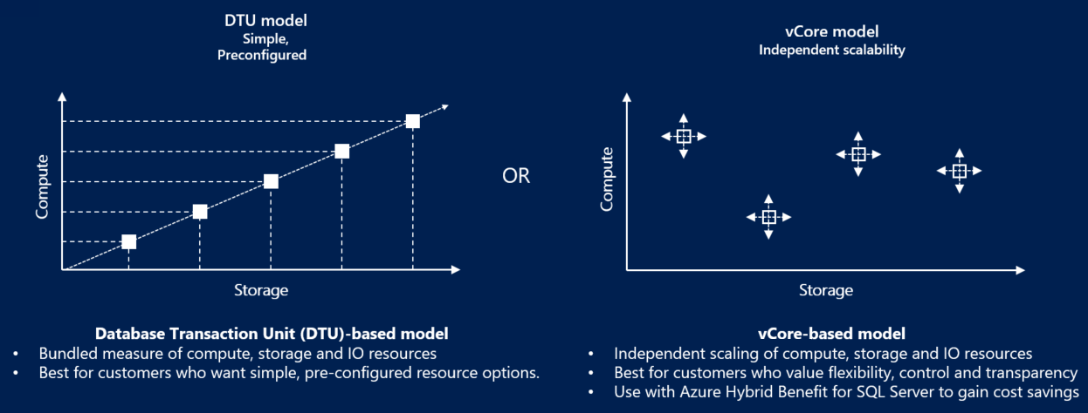

## DTU purchasing model

The DTU-based purchasing model uses a database transaction unit (DTU) to calculate and bundle compute costs.

**A database transaction unit (DTU) represents a bundled (aggregated) measure of CPU, memory, reads, and writes. The DTU-based purchasing model offers a set of preconfigured bundles of compute resources and included storage to drive different levels of application performance.**

If you prefer the simplicity of **a preconfigured bundle and fixed payments each month**, the DTU-based model might be more suitable for your needs.

In the DTU-based purchasing model, you can choose between the **Basic**, **Standard**, and **Premium** **service tiers** for Azure SQL Database. Review [DTU service tiers](https://learn.microsoft.com/en-us/azure/azure-sql/database/service-tiers-dtu?view=azuresql#compare-service-tiers) to learn more.

To convert from the DTU-based purchasing model to the vCore-based purchasing model, see [Migrate from DTU to vCore](https://learn.microsoft.com/en-us/azure/azure-sql/database/migrate-dtu-to-vcore?view=azuresql).

**vCore purchasing model**

A virtual core (vCore) represents a logical CPU and offers you the option to choose between generations of hardware and the physical characteristics of the hardware **(for example, the number of cores, the memory, and the storage size)**.

In the vCore-based purchasing model for SQL Database, you can choose between the **General Purpose**, **Business Critical**, and **Hyperscale** service tiers. Review [service tiers](https://learn.microsoft.com/en-us/azure/azure-sql/database/service-tiers-sql-database-vcore?view=azuresql#service-tiers) to learn more.

In the vCore-based purchasing model, your costs depend on the choice and usage of:

* Service tier
* Hardware configuration
* Compute resources (the number of vCores and the amount of memory)
* Reserved database storage
* Actual backup storage

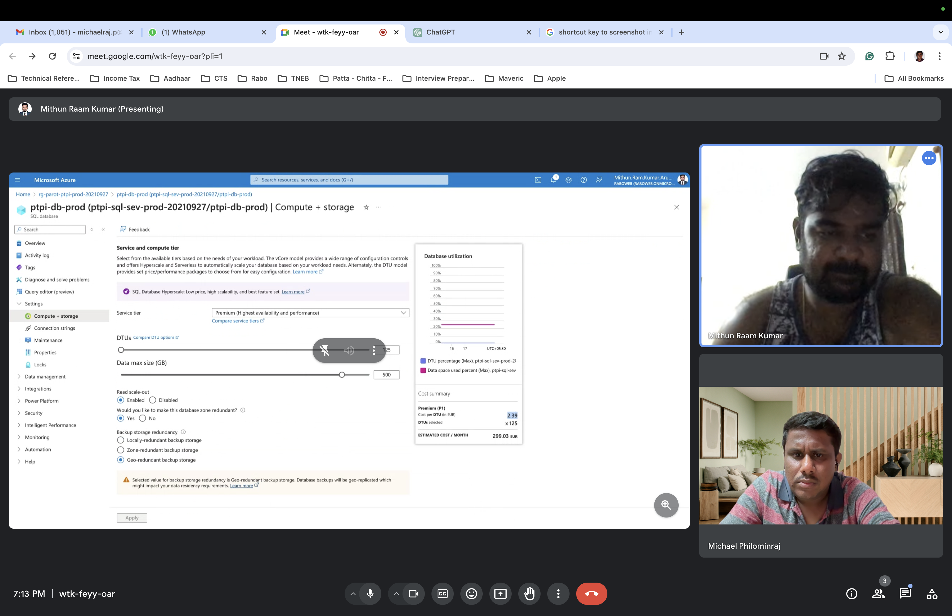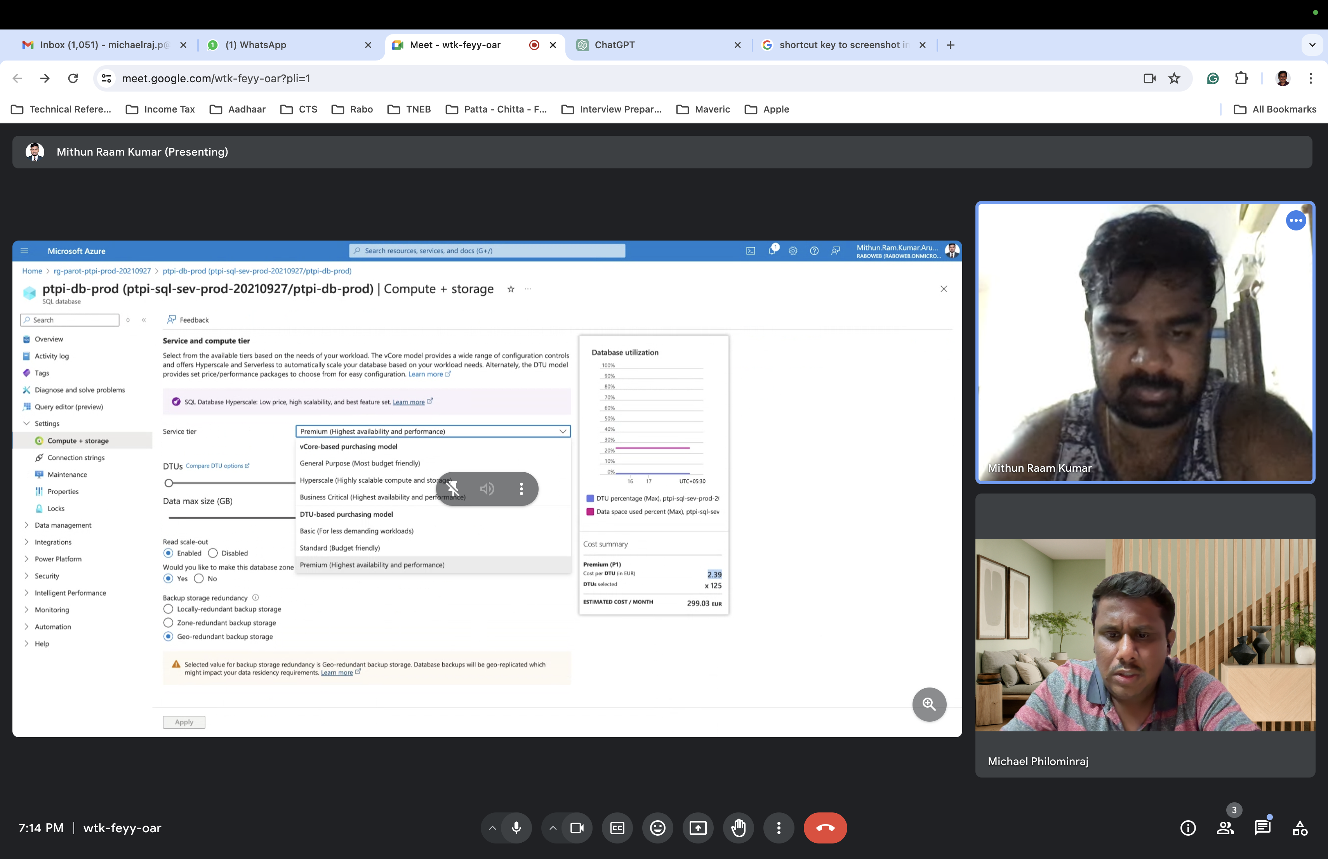

Azure provides pricing calculators and guidance to help you choose the most cost-effective option for your specific use case.

**Monitoring**

Alerts - we can set the alert emails on the usage cost (with defining a limit).

Metrics - Different types of metrics like **CPU Utilization Percentage, DTU Percentage and Data IO Percentage, Data Space Used.**

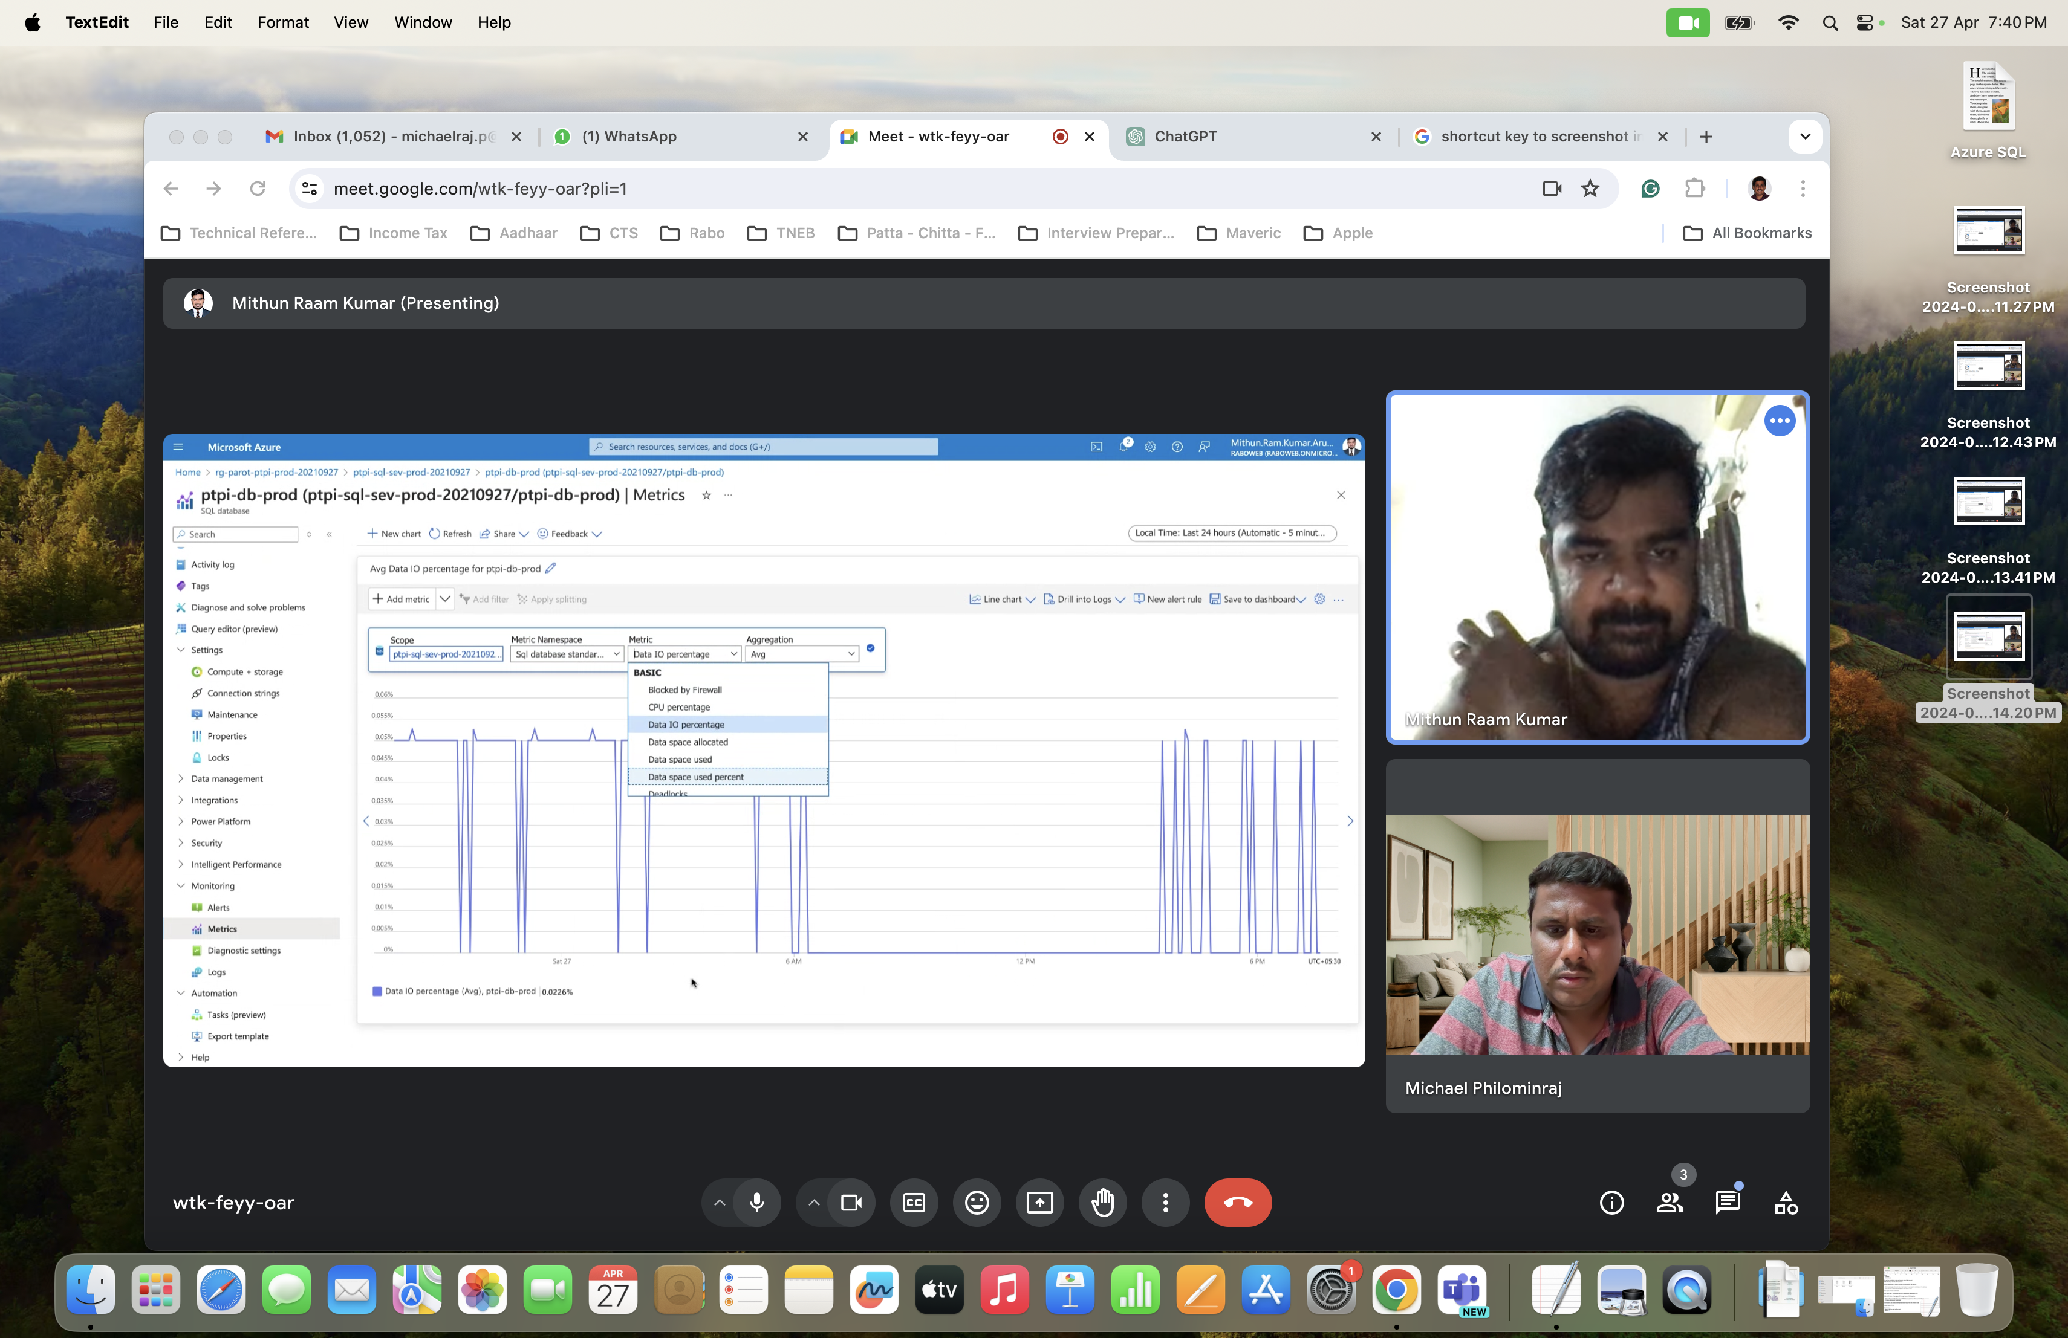**Data IO Percentage**

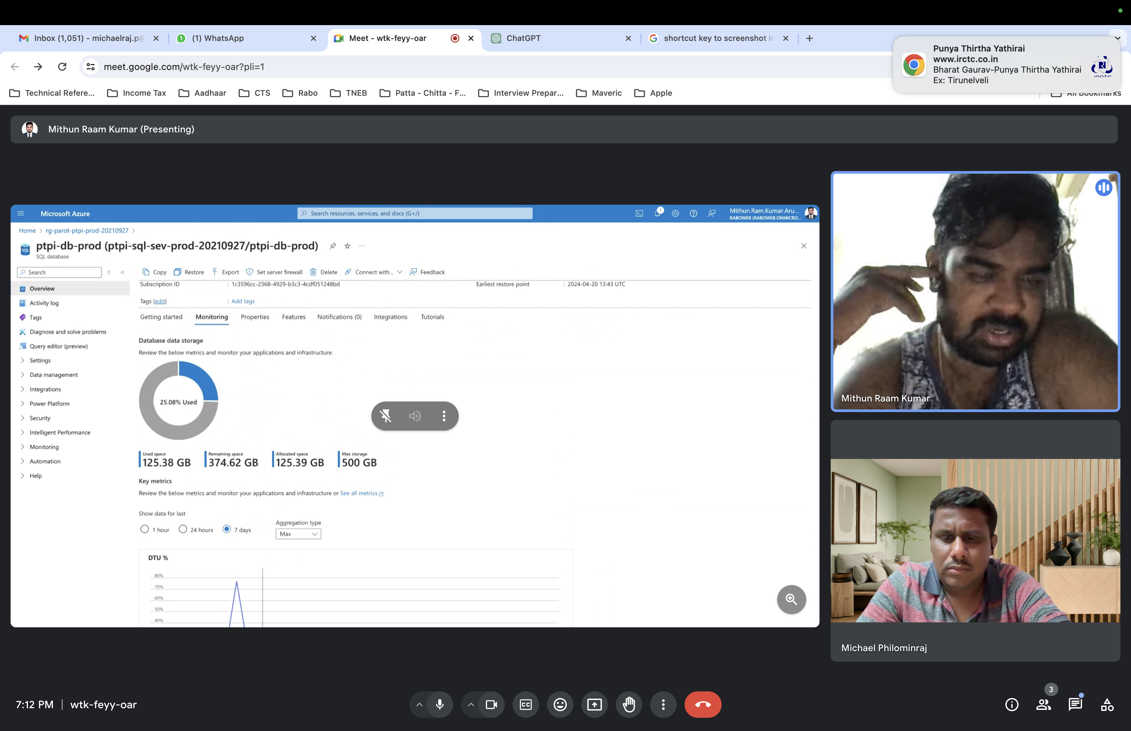**DTU Percentage**

**Logs - we can check different types of logs.**

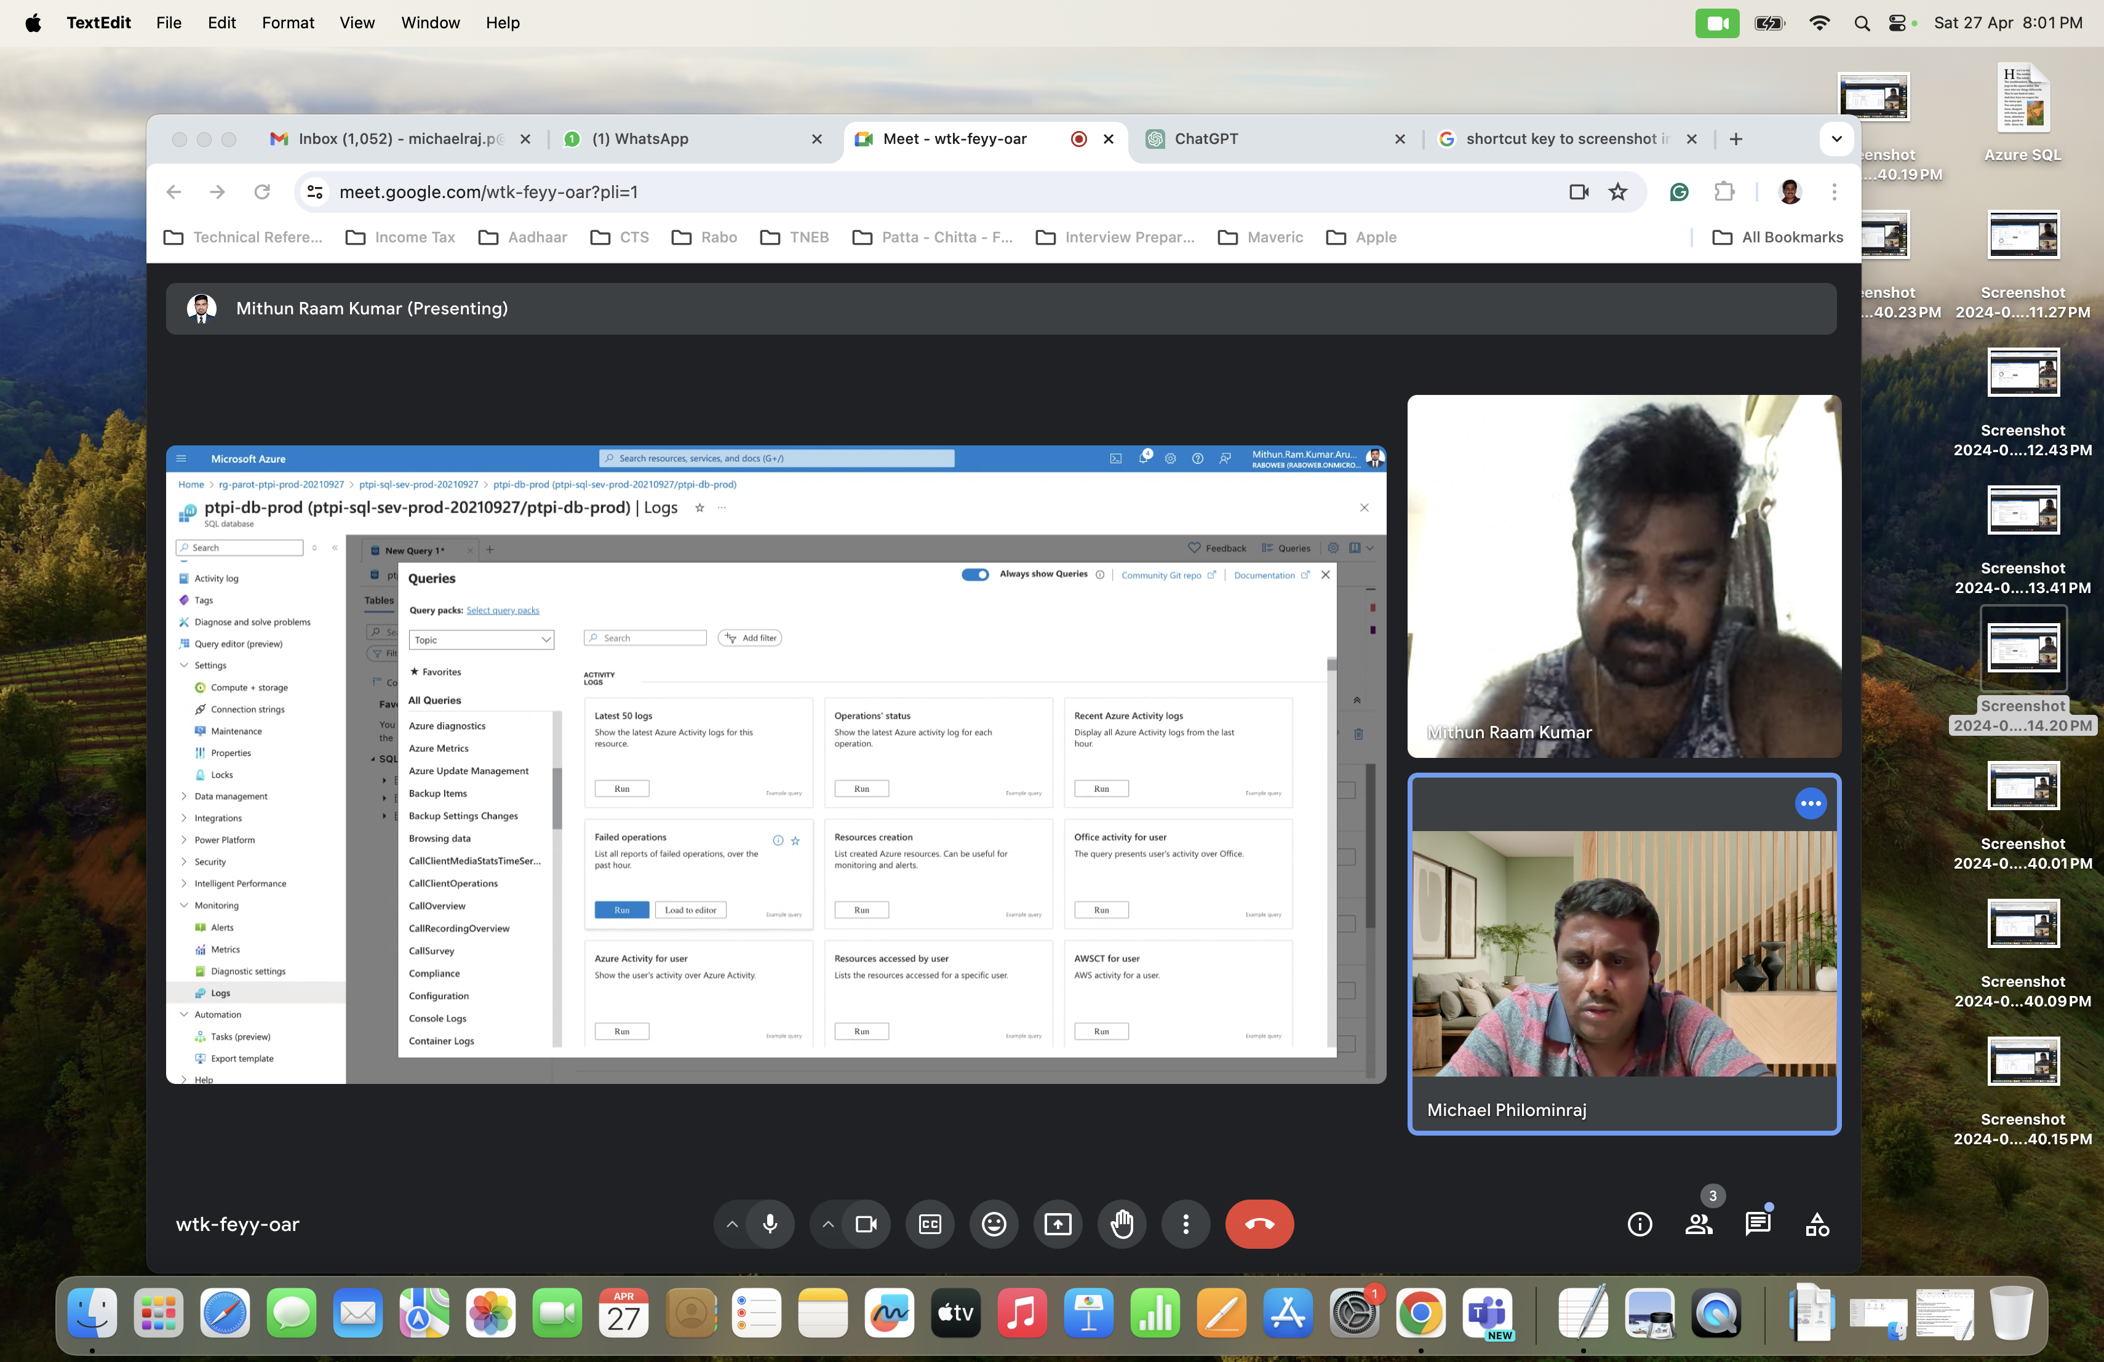

**Data Migration from On-Premises Oracle DB to Azure SQL Server in Cloud**

* Get access to **Jump VM server** and **Production VM server** where DB is in DMZ
* Configure the **Firewall** **of On-premises Production VM** for Outbound requeststowards **Azure Portal**
* And the same way, we need to configure **Firewall** **of** **Azure Portal** to allow the inbound requests from **On-Premises** **Production VM server.**
* Configure **Firewall** will whitelist the IP addresses
* Create the **Storage Account** (using this account, we can access the container/folder/files in Azure Blob Storage in Azure Portal)
* To create data factory instances, the user account you use to log in to Azure must be assigned a **Contributor** or **Owner** role or must be an **Administrator** of the Azure subscription.
* Use Azure Portal and create and configure **Azure Data Factory** using the **Azure Subscription** and the **Resource Group.**
* Use **Copy Data Tool** and create the **Pipeline (Task).**
* Pipeline/Task performs copying the data from Source data store (Oracle DB) to Destination data store (Azure SQL DB).
* The Task/Pipeline has 2 parts such as **‘Source data store’** and **‘Destination data store’.**
* As part of ‘Source data store’, Create a **‘LinkedService’ to Oracle DB to connect to Source data store.**
* As part of creation of **a ‘LinkedService’ to Oracle DB**, create and install **SHIR (Self Host Integration Runtime)** in On-Premises VM and register the same with **Azure Data Factory** using the **key**.
* SHIR will act as **an agent** in On-Premises VM in DMZ to connect to Oracle DB
* And then select the created SHIR to configure and create the ‘LinkedService’ to Oracle DB along with other required details such as **Server Name, DB Name, Authentication Type, User Credentials** to connect to DB.
* As part of ‘Destination data store’, Create a **‘LinkedService’ to Azure SQL DB to connect to Destination data store.**
* On the **Destination data store** page, configure the details of **Azure SQL DB** and **SHIR** to be used in the same way mentioned above.
* And then in the next step, select **Use existing table** and select the table from the list of Source data store as well as of Destination data source and then do column mapping.
* Name the **Task/Pipeline** with relevant name and then run the pipeline.
* On the **Summary** page, review the settings, and then select **Next** to move to the next step**.**
* On the **Deployment** page, select **Monitor** to monitor the pipeline (task).
* When the pipeline run completes, you can view the status of the pipeline you created.
* On the "Pipeline runs" page, select **Refresh** to refresh the list. Select the link under **Pipeline name** to view activity run details or rerun the pipeline.
* Verify that the data is inserted into the selected table in your SQL Database.
* Select the **Author** tab on the left to switch to the editor mode. You can update the linked services, datasets, and pipelines that were created via the tool by using the editor.

Refer the following links.

Migration Guide:

<https://learn.microsoft.com/en-us/azure/azure-sql/migration-guides/database/oracle-to-sql-database-guide?view=azuresql>

Supported data stores and formats:

<https://learn.microsoft.com/en-us/azure/data-factory/copy-activity-overview#supported-data-stores-and-formats>

# Compare vCore and DTU-based purchasing models of Azure SQL Database:

<https://learn.microsoft.com/en-us/azure/azure-sql/database/purchasing-models?view=azuresql>

# Copy data from a SQL Server database to Azure Blob storage by using the Copy Data tool:

https://learn.microsoft.com/en-us/azure/data-factory/tutorial-hybrid-copy-data-tool#prerequisites

# Copy data from Azure Blob storage to a SQL Database by using the Copy Data too:

<https://learn.microsoft.com/en-us/azure/data-factory/tutorial-copy-data-tool>

**Questions**

1.What is clustered index in Azure SQL DB?

In Azure SQL Database, a clustered index is a type of index that sorts and stores the rows of a table based on the key values. Unlike non-clustered indexes, which store only the index key values and a pointer to the actual data rows, a clustered index reorganizes the way records in the table are stored on disk so that the rows of the table are physically sorted based on the key values of the index.

When you create a clustered index on a table, the data rows are stored in the order of the clustered index key. This means that the rows themselves are physically sorted on disk based on the key values of the index. This can improve the performance of queries that use the clustered index key because it reduces the amount of data that needs to be read from disk.

However, it's important to note that a table can have only one clustered index, because the clustered index determines the physical order of the rows in the table. If you create a clustered index on a table that already has a clustered index, the existing clustered index is dropped and replaced with the new one.

2.What are the different types of auto generation methods used for Primary Key Generation?

There are several methods used for generating primary keys automatically:

1. **Identity Columns**: Also known as auto-increment or sequence-generated columns, these are columns where the database automatically generates a unique value whenever a new row is inserted into the table. In SQL Server, you can use **IDENTITY** columns, in PostgreSQL you can use **SERIAL** columns, and in Oracle you can use **SEQUENCE** objects.

2. **UUID/GUID**: Universally Unique Identifiers (UUIDs) or Globally Unique Identifiers (GUIDs) are generated by algorithms that are designed to ensure uniqueness across systems. These are typically **128-bit values** **represented as hexadecimal strings**. They are generated by the application before inserting a new row.

3. **Sequences**: Sequences are database objects used to generate unique integer values. They are commonly used in databases like Oracle and PostgreSQL. The application fetches the next value from the sequence before inserting a new row.

4. **Combination of Timestamp and Shard ID**: This method combines a timestamp (to ensure uniqueness across time) with a shard ID (to ensure uniqueness across different instances of the application) to generate unique primary keys.

5. **Custom Generation Logic**: Applications can implement custom logic to generate unique keys based on various factors, such as a combination of other columns, a hash of certain values, or a complex algorithm.

Each of these methods has its own advantages and considerations in terms of performance, scalability, and complexity. The choice of method depends on the specific requirements of the application and the database system being used.